28.61:
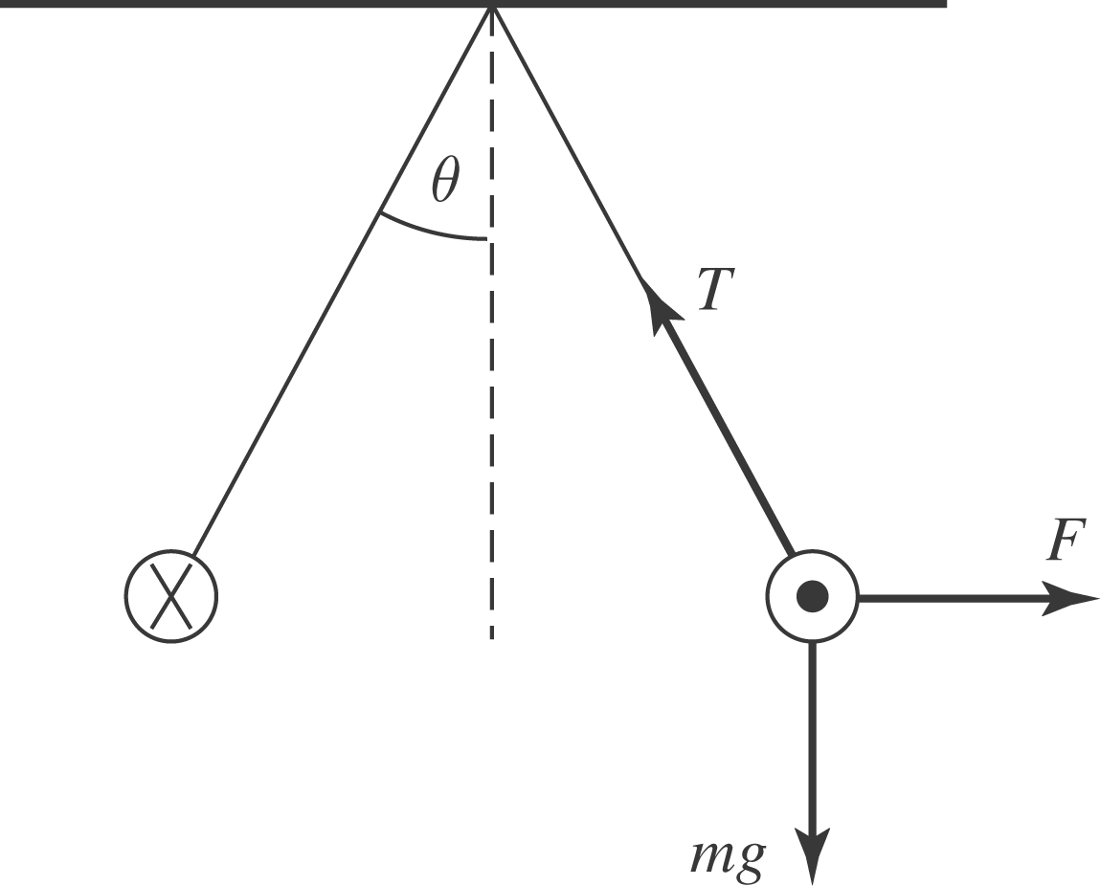

The wires are in equilibrium, so:

